January 28, 2022

Dear Parent or Guardian,

We are writing to inform you about a student survey that will be administered at your child’s school called the Illinois 5Essentials Survey. This is the tenth year the Illinois State Board of Education will implement this survey across the state. This survey is based on 20 years of research at the University of Chicago. It asks students about their experiences in school, giving school leaders critical student input to help develop school improvement plans.

Student participants will be required to log-in using their state student ID and birth date in order to complete the survey. Students’ identities will be completely confidential. Teachers or administrators will never see individual responses to survey questions and will only receive aggregated information, such as the total percentage of students who agree homework assignments help them learn the course material.

Please be aware that under the Protection of Pupil Rights Act. 20 U.S.C. Section 1232(c) (1) (A), you have the right to review a copy of the questions asked of your student(s). Survey questions can be found on the Illinois 5Essentials Support Center (https://impactsurveyshelp.force.com/s/article/illinois-5essentials-survey-questions).

If you do not want your student to participate, fill out the information below and return this sheet to the Principal’s office.

Thank you for your cooperation,
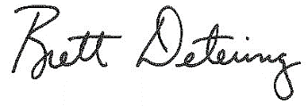

Brett Detering, Principal
Anna-Jonesboro Community High School

I DO NOT want my child, ____________________________, to take part in the 2021-22 Illinois
STUDENT NAME (PLEASE PRINT)
5Essentials Survey.

__________________________________ _____________ SIGNATURE OF PARENT OR GUARDIAN DATE

